

**QGIS Lab Series**

**GST 103: Data Acquisition and Management**

**Lab 3: Vector Data Quality**

**Objective – Learn to Verify the Quality of Vector Data with Topology Rules**

**Document Version:** **2014-08-16 (Final)**

**Author:**

Kurt Menke, GISP



**Contents**

1 Introduction 2

2 Objective: Learn To Verify the Quality of Vector Data with Topology Rules 2

3 How Best to Use Video Walk Through with this Lab 2

Task 1 Topology Rules - Part 1 2

Task 2 Topology Rules - Part 2 8

Task 3 Fixing Topology Errors 9

5 Conclusion 15

6 Discussion Questions 15

7 Challenge Assignment 15

1. Introduction

GIS data are referred to as models because they represent actual real world objects. It is important that they model the real world as accurately as possible. Often GIS datasets will have thousands of features. It can be challenging to verify the quality of such large datasets by visual means alone. Using topology rules we can test our data and ensure that it is well constructed.

This lab includes the following tasks:

Task 1 Topology Rules - Part 1

Task 2 Topology Rules - Part 2

Task 3 Fixing Topology Errors

1. Objective: Learn To Verify the Quality of Vector Data with Topology Rules

In this lab you will be explore the spatial relationship between point’s lines and polygons. You will be build topology rules and validate them to identify data errors.

1. How Best to Use Video Walk Through with this Lab

To aid in your completion of this lab, each lab task has an associated video that demonstrates how to complete the task. The intent of these videos is to help you move forward if you become stuck on a step in a task, or you wish to visually see every step required to complete the tasks.

We recommend that you do not watch the videos before you attempt the tasks. The reasoning for this is that while you are learning the software and searching for buttons, menus, etc…, you will better remember where these items are and, perhaps, discover other features along the way. With that being said, please use the videos in the way that will best facilitate your learning and successful completion of this lab.

1. Topology Rules - Part 1

In this task, you will use the Topology Rules plugin to investigate the quality of two datasets: bus routes and bus stops.

1. The data for this lab is located in: ***GST103\Lab_3\Data****.*
2. **Open QGIS Desktop** and **add** the **parcels.shp, Bus_stops.shp** and **Bus_routes.shp** layers to QGIS (**Figure 1**).

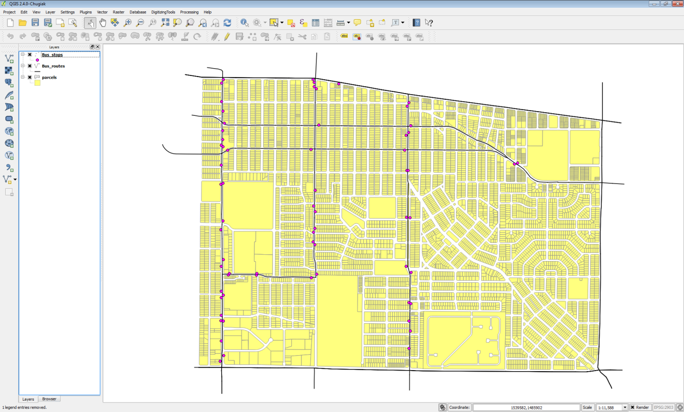

**Figure 1: Data Layers in QGIS Desktop**

1. **Save your project as Lab_3.qgs**
2. From the menu bar, choose **Plugins 🡪 Manage and Install Plugins**. **Select** the **Installed** tab and enable the **Topology Checker** plugin (**Figure 2**).

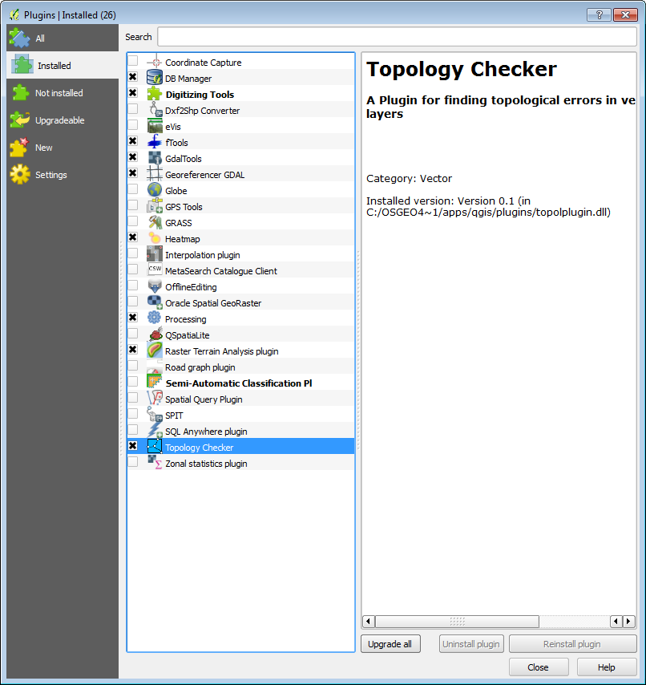

**Figure 2: Enabling the Topology Checker Plugin**

1. **Click** on the **Topology Checker**  button to open the **Topology Checker** **panel (Figure 3)**.

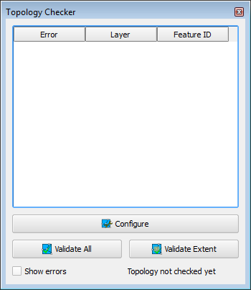

**Figure 3: Topology Checker Panel**

1. First, you will investigate the integrity of the Bus Stops layer. **Click** the **Configure** button at the bottom of the **Topology Checker** panel. This opens the **Topology Rules Settings** window. Here you can set up a variety of topology rules.
2. Under **Current rules** choose **Bus_stops** as the layer. **Click** the second drop down to see what topology rules are available for point layers. **Choose** ‘***must not have duplicates’***. This rule will check to make sure there are no stacked points, in other words, a bus stop situated directly over another. This type of error is difficult to identify without a topology rule. **Click** the **Add Rule** button to have the rule established (**Figure 4**)

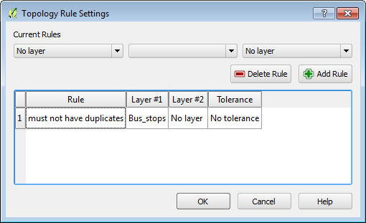

**Figure 4: Topology Rule Settings**

1. **Click** the **Validate All** button.

**NOTE**. You can also choose to zoom into a particular area and just validate the topology rule within the current extent by clicking instead the **Validate Extent** button.

1. The topology checker finds three duplicate geometries which are listed in the Topology Checker panel with their Feature ID’s and the rule they are violating. (**Figure 5**).

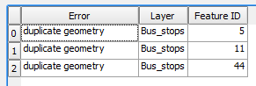

**Figure 5: Topology Errors Found**

1. Additionally the duplicated points are highlighted in red on the map. Again, these errors would be difficult to find any other way. However, once identified, they are easy to fix. Simply toggle on editing, select the duplicates and delete them.
2. Now you will examine the Bus_routes. **Click** the **Configure** button again. **Select** and **delete** the Topology rule for the **Bus Stops**. Now **create a new rule** for the **Bus_routes**, using ***must not have dangles***. This means the endpoint of a dangling line will be identified. You might expect that since these data are only a portion of an urban area, and there are bus routes heading off the map that those dangling endpoints will be identified. However, there should not be any in the middle of the network. **Click** the **Add Rule** button and **click OK (Figure 6)**.

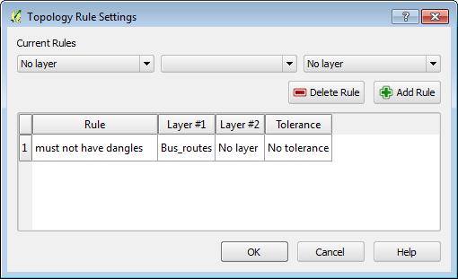

**Figure 6: Bus Route Topology Rule**

1. **Validate the topology**. The Topology Checker finds 25 errors of this type. Many are the expected ones, for example lines heading off the map edge. However, there are several in the middle of the network. See the black arrows on **Figure 7**. **Zoom in to some of these errors and investigate**.

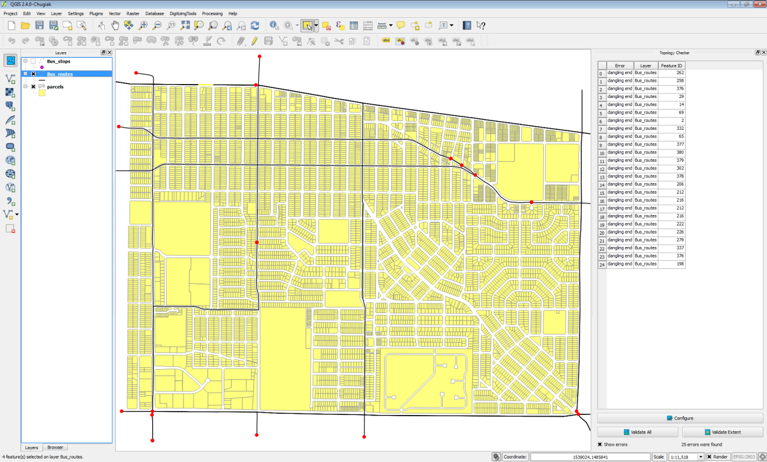

**Figure 7: Topology Errors Found**

1. **Save your map.**
2. Topology Rules - Part 2

Now you will implement topology rules to check the integrity of the parcels layer.

1. **Open** your **Lab3.qgs** project in **QGIS Desktop** if it not already.
2. **Click** on the Topology Checker to open the Topology Checker panel if not open already.
3. **Click the Configure button.**
4. **Select** any existing rules and **click** the **Delete Rule** button to remove them.
5. Configure three rules for the parcels layer: must not have gaps, must not overlap and must not have duplicates (**Figure 8**).

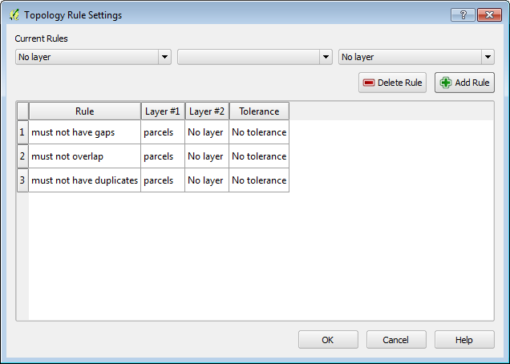

**Figure 8: Parcel Topology Rules**

1. **Click Validate All.**
2. The Topology Checker will report violations for each rule, seventeen errors in all.
3. **Save your project.**
4. Fixing Topology Errors

Now you will edit the parcel layer to eliminate these errors.

1. **Open** your **Lab3.qgs** project in **QGIS Desktop** if it not already.
2. **Re-validate** the topology rules if they are not appearing.
3. First, you will work on the duplicate geometries. **Right click** on the parcels layer and choose **Toggle Editing**.
4. **Double click** on the first duplicate geometry error in the **Topology Checker** to zoom into that location.
5. **Use the Select Feature by Rectangle tool  to select the duplicate parcels.**
6. **Open the parcel layer attribute table.**
7. **Change** the display filter in the lower right corner to **Show Selected Features**.
8. Notice that all the attributes are identical.
9. **Select** the feature with the **higher row number by clicking on it**. This leaves just one selected record. **Close** the **attribute table** and **click** the **Delete selected**  button to remove the duplicate parcel.
10. **Repeat steps 4-9 for the remaining duplicate geometry.** The attribute table should now show a total of 6968 records.
11. To fix the remainder you will need to go set your snapping tolerances. From the menu bar choose **Settings 🡪 Snapping Options**. **Uncheck** **Bus_routes** and **Bus_stops** so that snapping will be set only for parcels. **Set** the **Mode** for parcels to ***to vertex and segment*** and the **Tolerance** to **10 map units** (**Figure 9**) Also **check** ***Enable topological editing*** and ***Enable snapping on intersection***. Topological editing maintains common boundaries in polygon mosaics. With this option checked QGIS detects a shared boundary in a polygon mosaic and you only have to move the vertex once, and QGIS will take care of updating the other boundary.

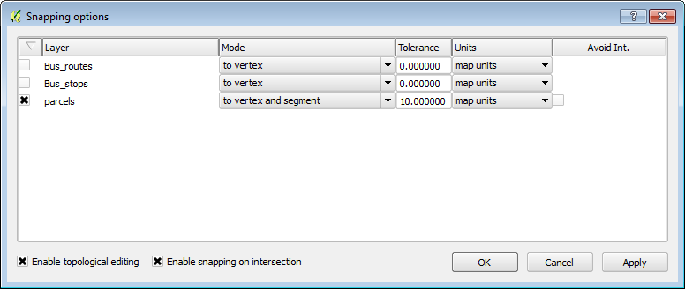

**Figure 9: Snapping Options**

1. From the menu bar **choose** **Settings 🡪 Options** and **click** on the **Digitizing** tab. **Set** the ***Search radius for vertex edits* to 10 (Figure 10).** Setting this to something other than zero ensures that QGIS finds the correct vertex when editing.

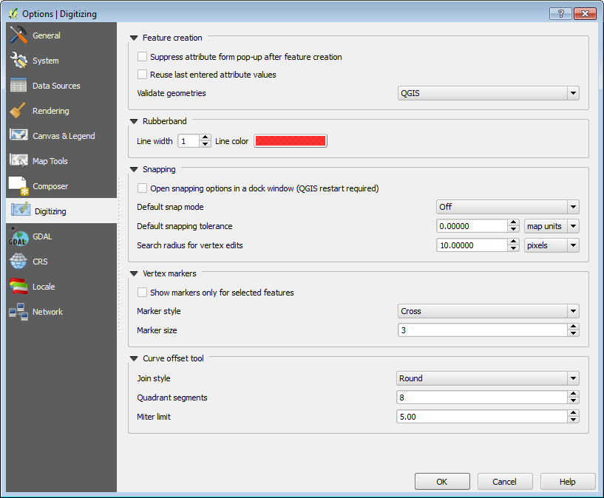

**Figure 10: Digitizing Options**

1. **Open** the **Layer properties** for the parcels layer and from the **Style** tab set the **transparency to 50%.**
2. **Uncheck** **Show errors** on the Topology Checker panel and **double click** on the error for Feature ID 624. The map will zoom to the location of the error. With errors turned off and the transparency set, you can see the overlap issue (**Figure 11**).

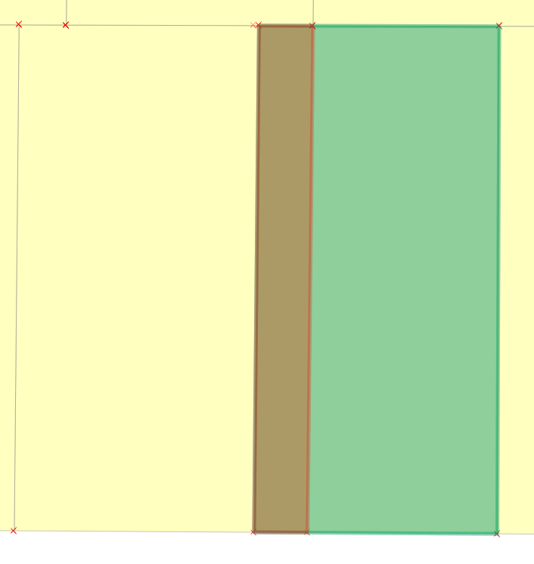 **Figure 11: Overlap Area for Feature ID 624**

1. There are two parcels involved in the overlap. Here the western (left) overlapping parcel boundary needs to be moved west (left) so that it does not overlap with the eastern parcel (parcel on the right).
2. **Use** the **Select Feature by Rectangle** tool  to select thewestern (left) overlapping parcel. The vertices of the selected feature will appear as red X’s.
3. **Click** on the **Node tool .** This tool allows you to move individual feature vertices. **Click** on a **vertex** of the **selected feature** and the vertices will show as red boxes (**Figure 12**).

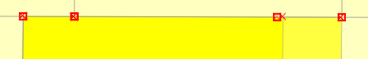

**Figure 12: Selected Vertices**

1. Click on the upper right vertex and the selected vertex and adjoining arcs will turn blue (**Figure 13**). Drag that selected vertex until it snaps to the boundary of the parcel it is overlapping.

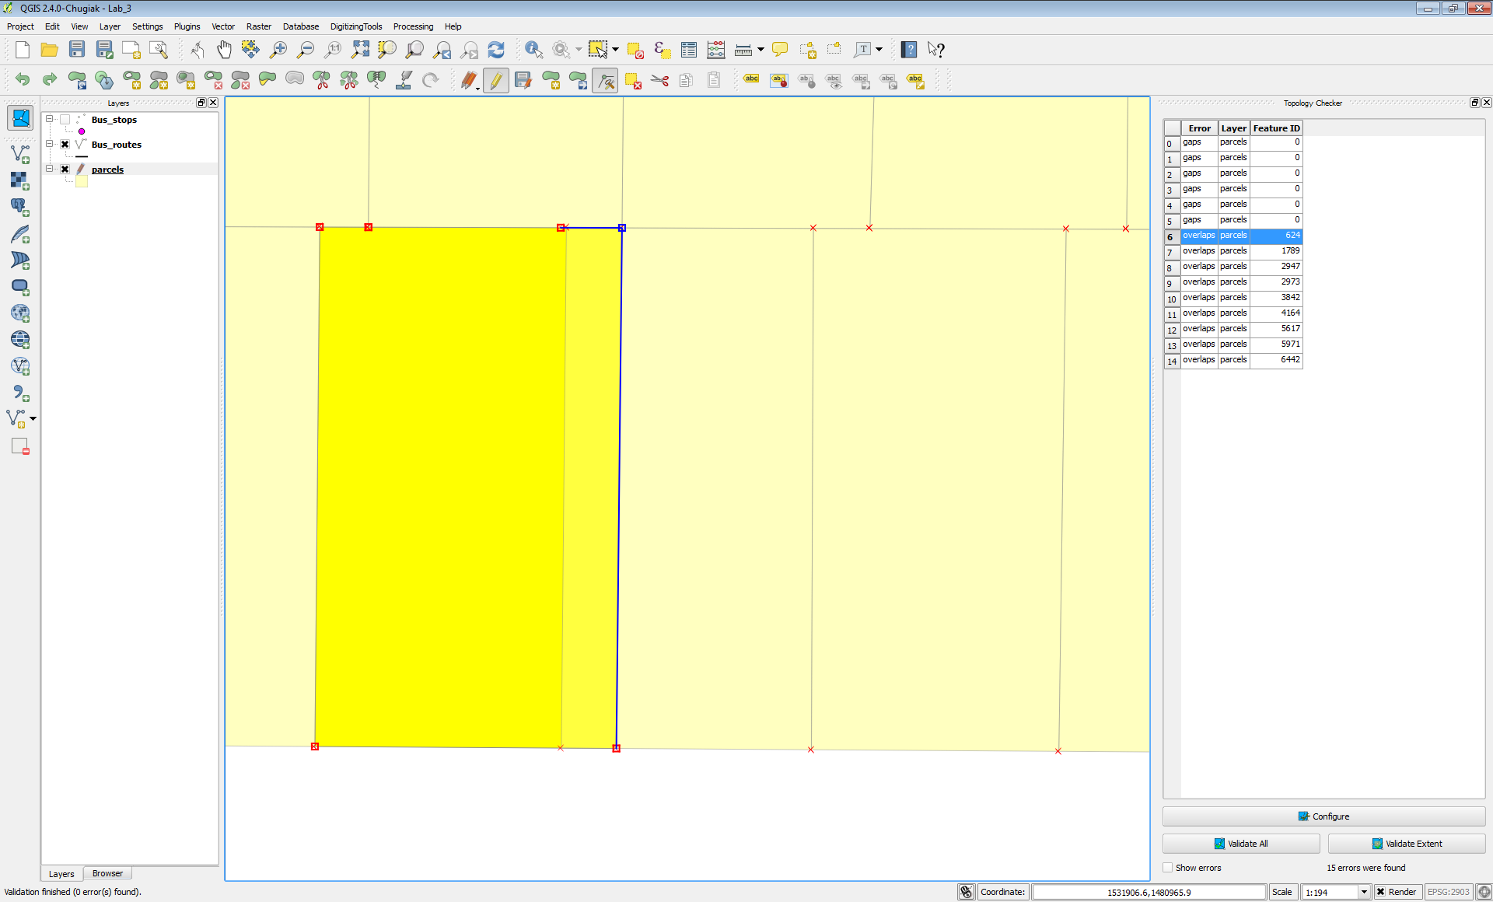

**Figure 13: Selected vertex with the Node tool**

1. **Repeat** for the **lower right vertex** and the overlap should now be resolved (**Figure 14**).

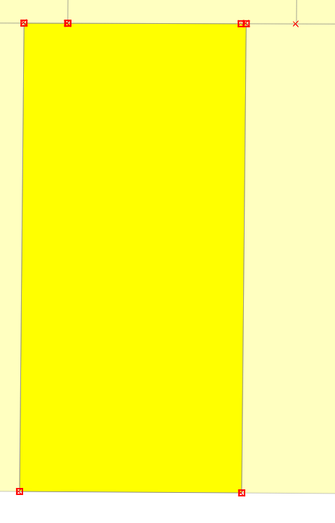 **Figure 14: Overlap Resolved**

1. **Click Validate Extent** in the Topology Checker panel to check and ensure that the overlap was taken care of. There is one other issue with this parcel. There is a tiny overlap in the northwest corner (**Figure 15**). This very small overlap cannot be seen at this scale. To resolve this, simply **select** the **affected vertices** with the **Node tool**, and **snap them back into place**. The overlap is so small you won’t see them move, however, the overlap will be resolved with due to the Topological editing setting.

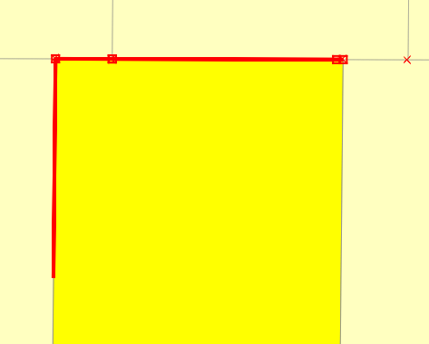

**Figure 15: Smaller Overlap Issue**

1. The remaining overlaps can be fixed in the same fashion.
2. From the **Topology Checker panel click** on the **first** **Gap error** in the list (for Feature ID 0). Again you will be zoomed to the location of the error (**Figure 16**).

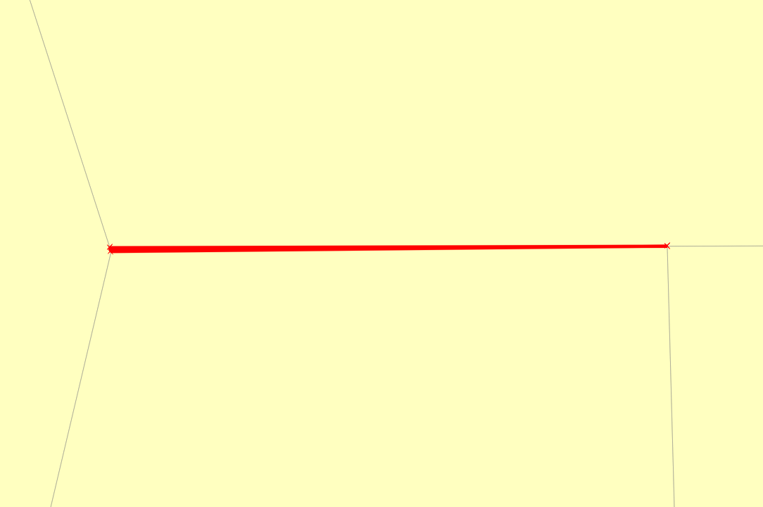

**Figure 16: Gap Error**

1. There is a small sliver between the parcels. **Select** the **parcel** to the **north** and **click** on the **Node tool. Uncheck Show errors.**
2. **Select the vertex in the southwestern corner of the selected parcel. Drag it until it snaps with the parcel vertex to the south, closing the gap.**

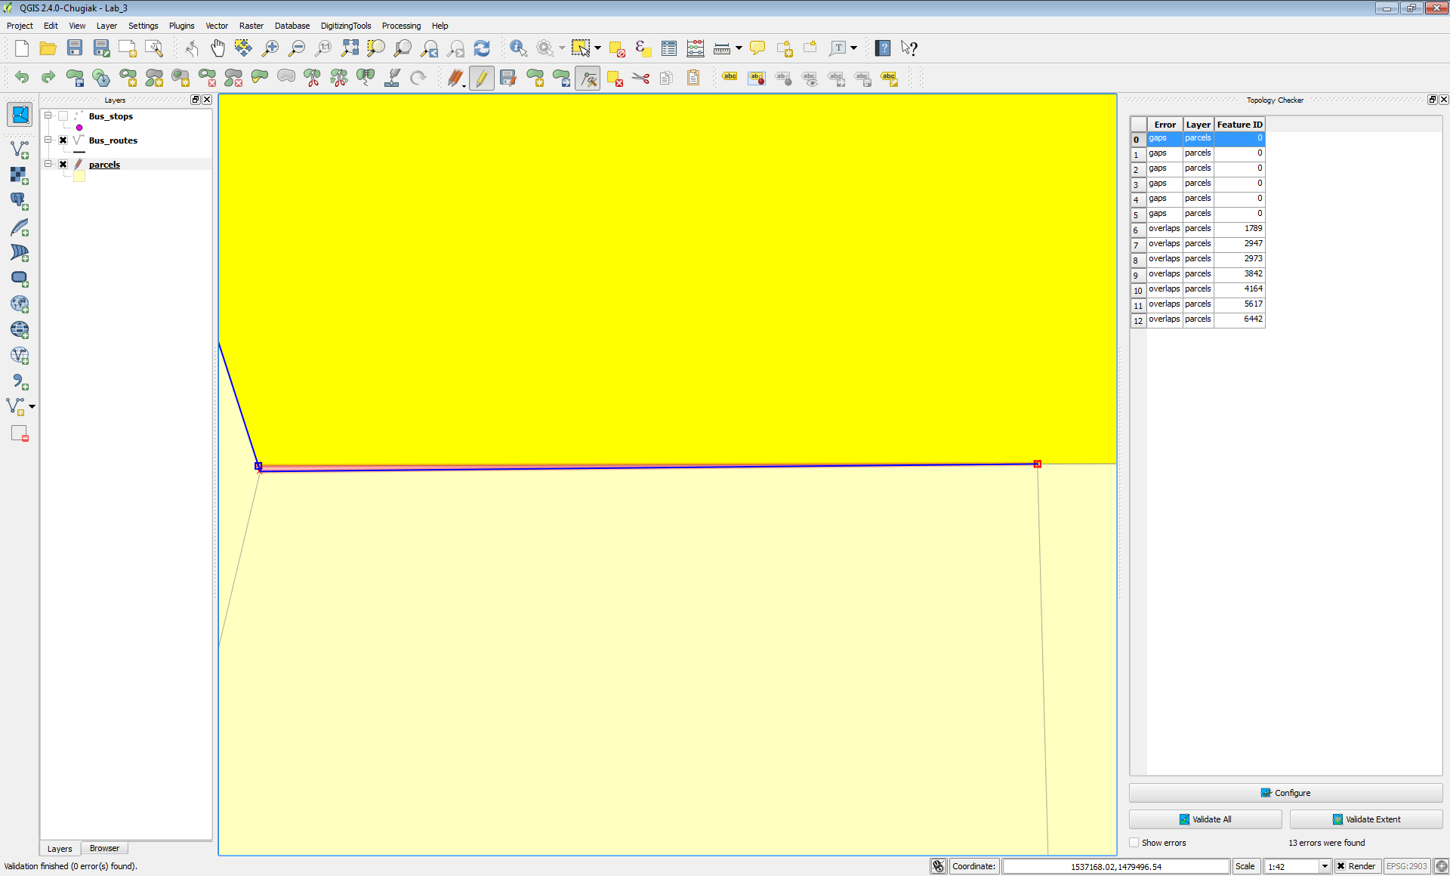

**Figure 17: Fixing the Gap Error**

1. **Click Validate extent** toensure that the issue has been resolved**.**
2. You can repair the other gap errors the same way.

5 Conclusion

In this lab, you learned how to test the integrity of your vector data with topology rules. These rules can involve features in two different layers or can be set to test the features in a single layer. There are different rules for points, lines and polygon features. You also learned how to use Topological editing to resolve the issues found.

6 Discussion Questions

1. What are the steps involved creating and testing a topology rule?
2. Explain the use of topology in industry.
3. How would topology be useful for property data?

7 Challenge Assignment

See if you can think of other topology rules that could be implemented against these data sets. Use topological editing to fix all the errors found.